A Low-Cost Approach to Autonomous Litter Collection

By James Heselden

Completed as part of a third year BSc in Computer Science

School of Computer Science

University of Lincoln

2019

Contents

Part A: Introduction and Background 3

Chapter 1: Introduction to Domain 3

Chapter 2: Background Domain Research 3

Part B: Methodology: 4

Chapter 3: Project Management 4

Chapter 4: Software Development Lifecycle 4

Chapter 5: Methodology Planning 5

Sub-System 1: Wireless Surveillance System and File Transfer 5

Sub-System 2: Background and Foreground Extraction 6

Sub-System 3: Object Identification and Litter Filter 8

Sub-System 4: SLAM System 9

Sub-System 5: Robot Development/Build 10

Sub-System 6: Robot Communication and Movement Systems 11

Part C: Conclusion 12

Chapter 6: Evaluation through Metrics 12

Chapter 7: Achieving the Aim 12

Chapter 8: Changes to Development 12

Part D: Reflective Analysis 12

Chapter 9: WW and EBI 12

Chapter 10: Further Research / Research Limitations 12

Part E: References 12

# Part A: Introduction and Background

## Chapter 1: Introduction to Domain

The aim of the project is to design and develop an autonomous system to deploy a robot to pick up litter. The project is focused around the requirements of the system being low-cost, low-maintenance, and high-efficacy. To ensure these requirements are met, special emphasis is placed on them during the decision-making processes throughout the development.

|  |
| --- |
| Abstract—Path motion object detection based on video is a fundamental part of intelligent transportation systems, In the aspect of background extraction, this paper compared all existing theories and algorithms, aimed at specific objects (city expressways or high-speed Road), and combined with the virtual loop set method. This paper proposed an extraction and updating algorithm based on the sub-segmentations of invariant background, which greatly increased the time efficiency of the background extraction. It achieved great results of accuracy and real-time of this algorithm under background extraction. |
| With the application of autonomy invading all areas, I say why not anti-littering  What are the biggest hurdles preventing autonomy in different areas?   * Cost? Effectiveness? Maintenance/Complexity? Social/Legal/Ethical?   This project plans to investigate, design and develop an autonomous system to deploy a robot to identify litter within an independent live video feed. |

## Chapter 2: Background Domain Research

**ESSENTIALLY A LIT REVIEW:**

A comprehensive review of literature will provide background to the project, and give weight to the decisions you have made.

This section establishes what you intended to do and shows the reader that what you have done is the result of academic study.

System Structure:

The first thing I need to contextualise, is why I set up the system in an isolated way. So why did I?

*What system structure could I have? Middleware approach? Review literature, and find some which talk about the benefits of a middleware approach to robotics and larger scale systems of interconnected systems…*

*Do a small critical evaluation of different middleware systems… Talk about how ROS is a good tool for connecting complex parts of a system together.* [*https://www.hindawi.com/journals/jr/2012/959013/*](https://www.hindawi.com/journals/jr/2012/959013/)

*Talk about and critically evaluate some basic cost reduction techniques like using cheaper materials and parts like USB webcam, over integrated circuitry on the robot.*

System Components:

Then I need to talk about why I split the project into the sub systems I did.

The specific implementations of each of the sub systems are described below, so the details on them I don’t need to worry about here. But I do need to describe why I chose to make each of these systems isolated.

*List off the individual sub-systems along with the system diagram.*

*Describe each one in turn, and describe what it contains, and why this is considered independent.*

*Try to find some benefits online and in research as to why this system should be independent.*

# Part B: Methodology:

## Chapter 3: Project Management

Gantt chart, time management, weekly goals, priority list, SE methodology evaluation

^ how did I use each of these?

## Chapter 4: Software Development Lifecycle

To ensure a successful project and artefact to boot, the structure of the implementation will follow a very strict regime with each sub-system as described before

## Chapter 5: Methodology Planning

The project follows a structure of isolation, where the system as a whole is broken down and the individual elements which make it up, have been developed independent from each other. For each of these systems, a review of best practices and methods was carried out, with an evaluation performed on the efficacy of each sub-system throughout the development.

The connection of the systems resembles the following diagram:

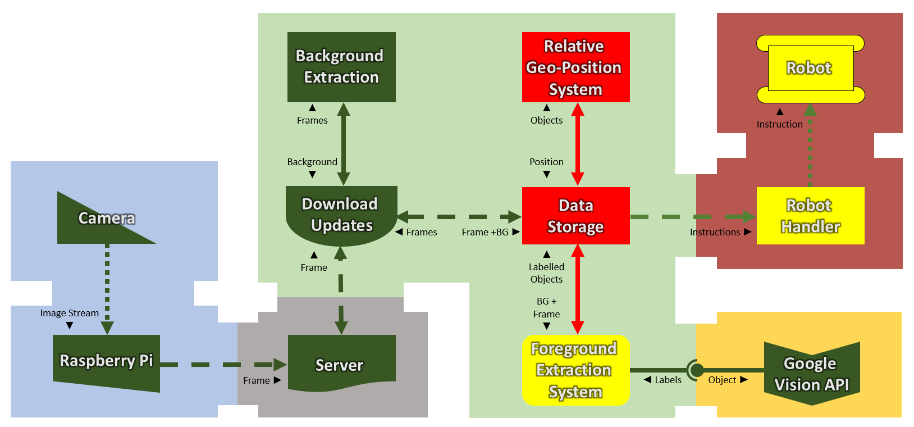

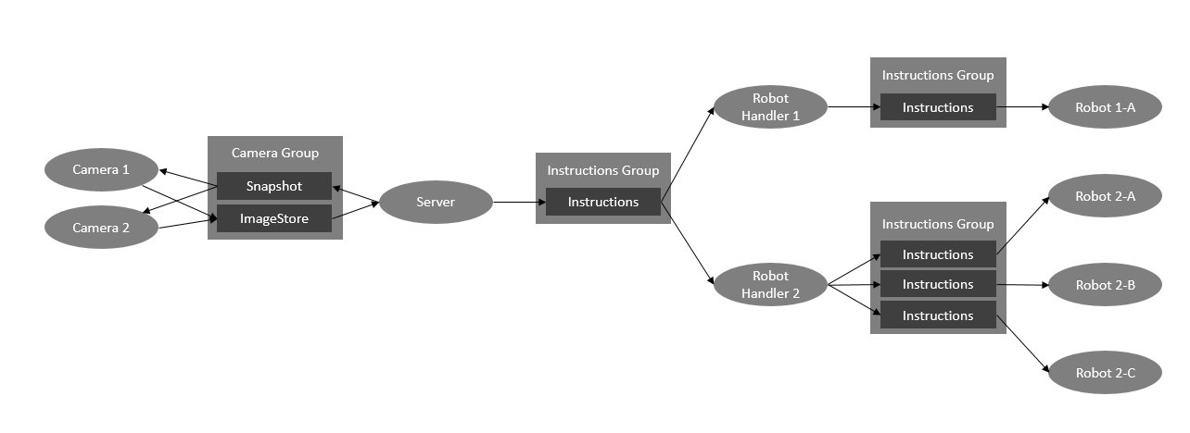

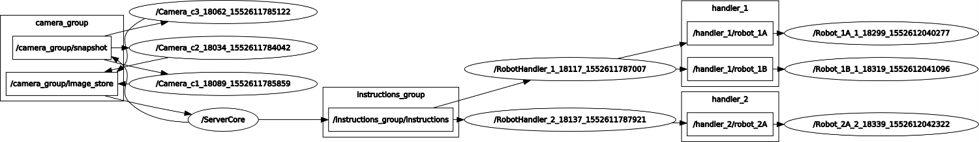

### Sub-System 1: Wireless Surveillance System and File Transfer

The first stage in the system’s architecture is the image acquisition. The initial idea was to mount the device chosen onto the robot, however after a risk

Was going to use Wired USB Camera but Changed to use (wireless)/Wi-Fi Camera as wired didn’t allow for having multiple cameras over a large area. This was simpler and easier to implement for cost reduction.

Changed to use Wired USB Camera connected to RPI as it was easier than connecting cam to internet or setting up own campus-wide subnet or adding own routers for each Wi-Fi cam.

Was going to use FTP to connect directly with desktop… didn’t have admin perms to do so, so for the sake of the report a server is used as a middle ground where the cam publishes to, and the processing unit subscribes to.

Update speed justification…?

|  |
| --- |
| RESEARCH POINTS: |

#### Step 1: Research tools and methods to set up the sub-system

#### Step 2: Define appropriate evaluation systems

#### Step 3: Define requirements for the sub-system

#### Step 4: Design the sub-system using the best method

#### Step 5: Test effectiveness of systems researched in context

#### Step 6: Build the most appropriate

#### Step 7: Evaluate the efficacy of the sub-system

### Sub-System 2: Background and Foreground Extraction

Significant research concluded for this…

Various image stacking algorithms have been tested beginning with mean stacking, it was removed as a day-night cycle and weather shifts would drastically change the overall appearance of the images.

Entropy blurring was attempted but the implementation for such a system meant the quality of images were reduced making small objects harder to identify.

Stacking with edge detection was tested, however for it to work the quality of the camera needed to be improved, and the material patterns on the floor, greatly impacted the quality of the output.

Mode stacking on a relatively small timed cycle was found to be the most effective and allow the smallest impact of changes. The only issue currently remaining is random parts have high values when they should not… so more development needs to be put into making this work smarter. The maths behind why this is so effective at detecting change stems from the lack of maths. Mean is impacted by random sparks, and when there is a lot of change, it cannot identify the background. While mode is not impacted by random changes. It takes what is most static in the frame-set, which should always represent the background.

Foreground Extraction is background subtraction. It is simply the new frame minus the background, where the value is 0 or near-0 then there is no change and should be disregarded.

|  |
| --- |
| RESEARCH POINTS: |

#### Step 1: Research tools and methods to set up the sub-system

#### Step 2: Define appropriate evaluation systems

#### Step 3: Define requirements for the sub-system

#### Step 4: Design the sub-system using the best method

#### Step 5: Test effectiveness of systems researched in context

|  |
| --- |
|  |

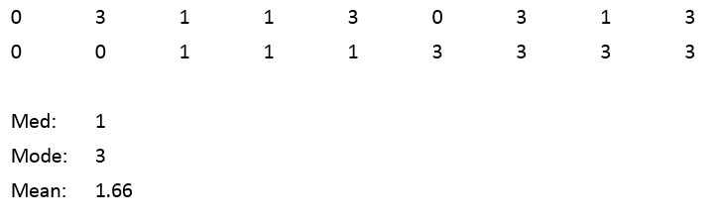

#### Step 6: Build the most appropriate

#### Step 7: Evaluate the efficacy of the sub-system

### Sub-System 3: Object Identification and Litter Filter

Object identification was originally planned to extract many features form the objects and apply SVM on them to classify against a dataset or labelled data. This was changed to use the Google Vision API, as the dataset of labelled data and its accuracy is much higher then what could be achieved in the time frame.

I may come back to it later on in the project and develop a custom model from the Google ML API.

For the litter filter; essentially, I need to list out all valid matches…. How do I choose what is defined as trash though? TESTING WITH RESPONSES FROM GOOGLE VISION API REQUIRED 2

|  |
| --- |
| RESEARCH POINTS: |

#### Step 1: Research tools and methods to set up the sub-system

#### Step 2: Define appropriate evaluation systems

#### Step 3: Define requirements for the sub-system

#### Step 4: Design the sub-system using the best method

#### Step 5: Test effectiveness of systems researched in context

#### Step 6: Build the most appropriate

#### Step 7: Evaluate the efficacy of the sub-system

### Sub-System 4: SLAM System

I kindda have an idea. We use the footage from the camera to find the relative position of the trash returned from the object identification and calculate how much the robot must rotate until its head and tail line up pointing at the trash. Then we move it forward until it hits the trash.

|  |
| --- |
| RESEARCH POINTS:  [ <https://en.wikipedia.org/wiki/List_of_SLAM_Methods> ] |

#### Step 1: Research tools and methods to set up the sub-system

#### Step 2: Define appropriate evaluation systems

#### Step 3: Define requirements for the sub-system

#### Step 4: Design the sub-system using the best method

#### Step 5: Test effectiveness of systems researched in context

#### Step 6: Build the most appropriate

#### Step 7: Evaluate the efficacy of the sub-system

### Sub-System 5: Robot Development/Build

Decided to begin with the low-cost approach of using a basic toy off-the-shelf £12 RC car, and rewiring it. Breadboarding a motor driver chip to control it was not successful and broke the Pi, diodes, LEDs, and breadboard. So, decided to look for pre-built alternatives, many worked off of Arduino Uno, and this gave me an idea of prices. I bought a kit for £30, however it did not include the electronics or any assembly instructions, so it was returned. A motor control board was bought prebuilt for £10.

… PENDING RESULTS…

|  |
| --- |
| RESEARCH POINTS:  <https://www.amazon.com/gp/product/1457186039/ref=as_li_qf_sp_asin_il_tl?ie=UTF8&camp=1789&creative=9325&creativeASIN=1457186039&linkCode=as2&tag=therobpod-20&linkId=QHNJA3OMPG5P7T4Z> |

#### Step 1: Research tools and methods to set up the sub-system

#### Step 2: Define appropriate evaluation systems

#### Step 3: Define requirements for the sub-system

#### Step 4: Design the sub-system using the best method

#### Step 5: Test effectiveness of systems researched in context

#### Step 6: Build the most appropriate

#### Step 7: Evaluate the efficacy of the sub-system

### Sub-System 6: Robot Communication and Movement Systems

#### Step 1: Research tools and methods to set up the sub-system

#### Step 2: Define appropriate evaluation systems

#### Step 3: Define requirements for the sub-system

#### Step 4: Design the sub-system using the best method

#### Step 5: Test effectiveness of systems researched in context

#### Step 6: Build the most appropriate

#### Step 7: Evaluate the efficacy of the sub-system

# Part C: Conclusion

## Chapter 6: Evaluation through Metrics

## Chapter 7: Achieving the Aim

## Chapter 8: Changes to Development

# Part D: Reflective Analysis

## Chapter 9: WW and EBI

## Chapter 10: Further Research / Research Limitations

# Part E: References